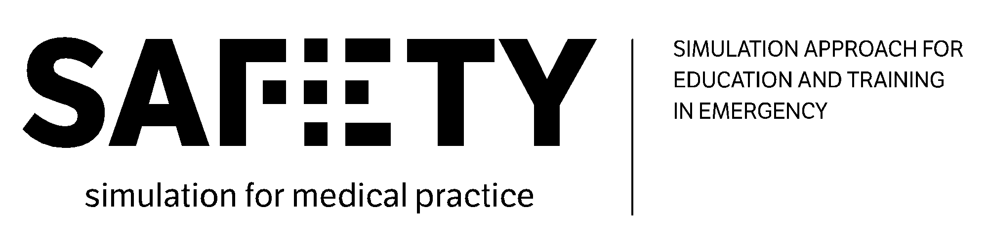
7th Virtual Meeting
23 May 2022

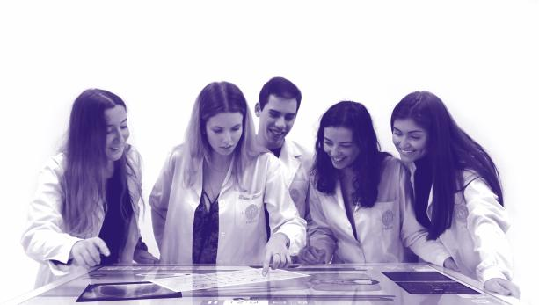
-----------------------------------------------
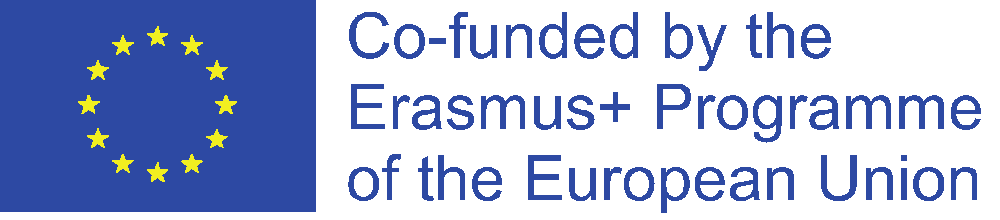
The European Commission's support for the production of this publication does not constitute an endorsement of the contents, which reflect the views only of the authors, and the Commission cannot be held responsible for any use which may be made of the information contained therein.

Agenda:

- WP3: Updates on the theoretical modules and simulation cases preparation (All partners).

Participants:
- University of Foggia (UNIFG) represented by Fedele Colantuono, Francesco Barberio, Lucia Mirabella, Gilda Cinnella, Antonella Cotoia, Eva Epifani;
- University Clinic Hospital of Barcelona (CBHU) represented by Beatriz Tena and Lidia Gomez;
- “Prof. Dr. CC. Iliescu” Emergency Institute for Cardiovascular Diseases (EICD) represented by Mihai Stefan;
- Ludwig-Maximilians University of Munich (LMU) represented by Katarina Grujic and Fischer Philipp;
- University of Stavanger (UIS) represented by Camilla Normand;
- ValueDo (VALUE) represented by Giuditta Pasta;
- Take the Wind (TWW) represented by Rita Flores;
- Infotech (INFO) represented by Antonio Scrocco.

WP3: Updates on the theoretical modules and simulation cases preparation
Katarina (LMU) recaps the main conclusions of last meeting and reminds the partners that the final list of the allocation of simulation cases among the partners is available here:
https://docs.google.com/spreadsheets/d/1za53KqvFgqFCWbPx3fSQ89eflidBZsOG7DtDr_N10y0/edit#gid=0

All the partners approve the distribution of the work referring to both the theoretical modules and the simulation cases. All the Universities can now start working on 2 modules and 5 scenarios assigned to them.

The pilot learners should be students from Medicine and Nurse Faculties. The level of the students is whether professionals or residents. To have a common basis we should primarily aim to have undergraduate students. As in some countries (e.g. Romania), the residents are affiliated with universities, we can think of the second level of scenario also for residents. Also the training need analysis was addressed to the students of the last year of Medicine and Nurse Faculties and to the first-year resident students.

Final remarks on the templates for theoretical modules and simulation cases:
- The expected length/duration for the students to go through the theoretical modules should be one teaching hour (around 45 minutes).
- The partners should have a common slide for defining guidelines for the debriefing session, even if the partners will be free to decide how to organize the debriefing sessions. LMU will send a proposal to the partners by the next week.
- The partners will make available an additional module dedicated to the following skills: Leadership and Group Work, lasting around 15-20 minutes each. UniFg will take care of these additional modules.
- All the training materials should be in English.
- The partners agree to have the training materials revised internally by one peer-reviewer for each theoretical module and simulation case. The list of peer-reviewer will be proposed by LMU in the next few days. After the internal reviews, the training materials will be subject to an external review to be organized by EICD, referring to T3.5.
The partners agree on these new deadlines:

- Partners to develop the first version of the training materials (theoretical modules) according to R3.1: 10.06.2022;
- Peer-reviewers to revise the training materials (theoretical modules) prepared by the other organizations: 24.06.2022;
- Partners to deliver the final version of the training materials (theoretical modules) by 15.07.2022;
- Partners to develop the first version of the training materials (practical modules) according to R3.1 by 24.06.2022;
- Peer-reviewers to revise the training materials (practical modules) prepared by the other organizations by 08.07.2022;
- Partners to deliver the final version of the training materials (practical modules): 22.07.2022.
All the deadlines are available here:
https://docs.google.com/spreadsheets/d/16uvddontG8I6_xeAp4BVCkDGWy0p60TVJEYsW9Pb6PU/edit#gid=0.

Fedele reminds the partners to fill in the Doodle for the meeting in Coimbra (available here:
https://doodle.com/meeting/participate/id/dNkqN5ve?authToken=Z2l1ZGkucGFzdGFAZ21haWwuY29tO0dpdWRpdHRhIA%3D%3D.9KB65kgGZXrK7gGKYI).

