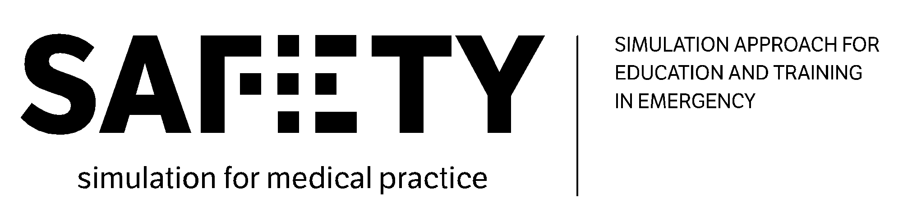
5th Virtual Meeting
20th October 2021


-----------------------------------------------

The European Commission's support for the production of this publication does not constitute an endorsement of the contents, which reflect the views only of the authors, and the Commission cannot be held responsible for any use which may be made of the information contained therein.

Agenda:
- WP1 - Updates and presentation of the first draft of "R1.4 Report on education & training convergences and divergences, literature review and company good practices in Emergency" (HUBC and UiS);
- WP2 - Presentation of the first draft of the Training Needs Analysis (UNIFG);
- WP2 - Presentation of the index of the Body of Knowledge (UNIFG);
- WP6 - Planning the in-person meeting in Munich (LMU + All partners);
- WP3 - Presentation of the overall framework for the SAFETY courses and work-plan for WP3 implementation (LMU);
- WP8 - Updates on the external evaluation process (EICD).

Participants:
- University of Foggia (UNIFG) represented by Francesco Barberio, Roberto Caporusso, Fedele Colantuono. Gianluigi De Pascale, Giacomo Errico, Lucia Mirabella;
- University Clinic Hospital of Barcelona (CBHU) represented by Juan Perdomo, Lidia Gomez, Cristina Ibanez, Beatriz Tena and Sara Darriba;
- “Prof. Dr. CC. Iliescu” Emergency Institute for Cardiovascular Diseases (EICD) represented by Mihai Stefan, Cornelia Florescu, Robu Cornel and Liana Valeanu ;
- Ludwig-Maximilians University of Munich (LMU) represented by Marc Lazarovici and Katarina Grujic;
- University of Stavanger (UIS) represented by Camilla Normand, Une Stømer, Thor Ole Gulsrud and Nina Vatland ;
- ValueDo (VALUE) represented by Giuditta Pasta and Alessandro Guadagni;
- Take the Wind (TWW) represented by Rita Flores and Ana Santa;
- Laerdal (LAE) represented by Novella Callero;
- Alpha Medical Concepts (AMC) represented by Lukas Drabauer;
- Infotech (INFO) represented by Antonio Scrocco.

WP1 - Updates and presentation of the first draft of "R1.4 Report on education & training convergences and divergences, literature review and company good practices in Emergency" (HUBC and UiS)

Juan starts presenting all the achievements and findings of the analysis carried out by HUBC (full presentation available here).
The main conclusions can be summed up as follows:
- Conclusion I:
  - The majority of the offer come from public universities and hospitals;
  - Public hospital offer is not homogenous across the five countries (Germany);
  - Public university offer is not homogeneous across the five countries (Romania)
  - Private simulation center offer is not homogeneous across the five countries (Italy)
  - Public simulation center offer is not homogeneous across the five countries (Norway)
- Conclusion II:
  - Undergraduate nurses and physicians have a lower percentage of courses targeting them
  - Public universities show a statistically significant tendency to have more courses targeting undergraduate physicians and nurses
  - Public hospitals show a statistically significant trend to have fewer courses targeting undergraduate physicians and paramedics
  - Private universities show a statistically significant tendency to have more courses targeting nurses
  - Public and private simulation centers show a statistically significant trend to have more courses targeting paramedics
- Conclusion III:
  - Courses related to anaesthesiology-intensive care (I), cardiology (G), obstetrics (I), and emergency management (N) show a statistically significant difference in distribution across countries
  - Public hospitals show a statistically significant tendency to have more courses related to anaesthesiology-intensive care, cardiology and pediatrics.
  - Public simulation centers show a statistically significant tendency to have fewer courses related to emergency management.
- Conclusion IV:
  - Half of the emergency educational offers include simulation
  - It seems that the use of simulation allows approaching NTS alone and with TS more frequently than courses without simulation
  - Courses are more likely to target skills related to “diagnosis and treatment” and ”clinical reasoning” if they are linked to NTS.
  - There is a significant tendency of courses that include simulation not to target “team-patient communication” and “team-relatives communication”
Camilla (UiS) shows the first draft of the report UiS is preparing on the best team composition in emergency and the Ryyan platform used by the partners for the research task in WP1. Camilla points out that the very interesting thing is that there are no articles focusing only on simulation: the majority of them are about trauma, so the articles mention more “trauma team” instead of “optimal team composition in emergency”. So, mainly the articles focus on the necessary members for the trauma team: different hospitals have different trauma teams, based on the trauma each team needs to deal with. There is a lot of literature also on the “Trauma team Leader” (in many cases this role is covered by a senior nurse) and on the pediatric trauma team. So, the work done shows that there is a huge heterogeneity in the field of medical team composition.
She communicates that there are still 15 articles to be screened and that, for the moment, did not receive any feedback. Camilla shows the two options the partners have in front now:
- Consider the analysis of the articles concluded, transfer the draft of the report on a Google sheet document and let the partners comment it on track change modality;
- Complete the literature review and screen the 15 articles left. Afterward, UiS would share the first draft of the report, transfer it on a Google sheet document and let the partners comment it on track change modality.
As the articles to be analyzed are not so many, the partners agree to continue with the literature review and publish the final report. Furthermore, completing the literature review reading the last articles, would make the comparison between the report of WP1 and the BoK exhaustive and efficient.
Camilla will contact the partners that need to carry out the analysis of the articles and then, once the work is completed, she will transfer the report on a Google sheet document to let the partners comment it on track change modality.
Next deadlines:
- UIS to deliver R1.4 Report on education & training convergences and divergences, literature review and company good practices in Emergency by 10.11.2021;
- HUBC to prepare the report on the desk research on education and training analysis by 10.11.2021.
WP2 - Presentation of the first draft of the Training Needs Analysis (UNIFG) and presentation of the index of the Body of Knowledge (UNIFG)
Francesco (UniFg) introduces the main findings of the training needs analysis conducted by UNIFG (full presentation available here). Gianluigi (UniFg) shows more in detail the results of the survey to students, academics and Fedele introduced the companies survey main achievements. At the end of the analysis, 1464 students, 288 academics and 23 companies have been reached. Gianluigi also shows how to interpret the results, considering how the questions impact each of the eight attributes (ATT*) assessed for understanding the preference of the respondents.
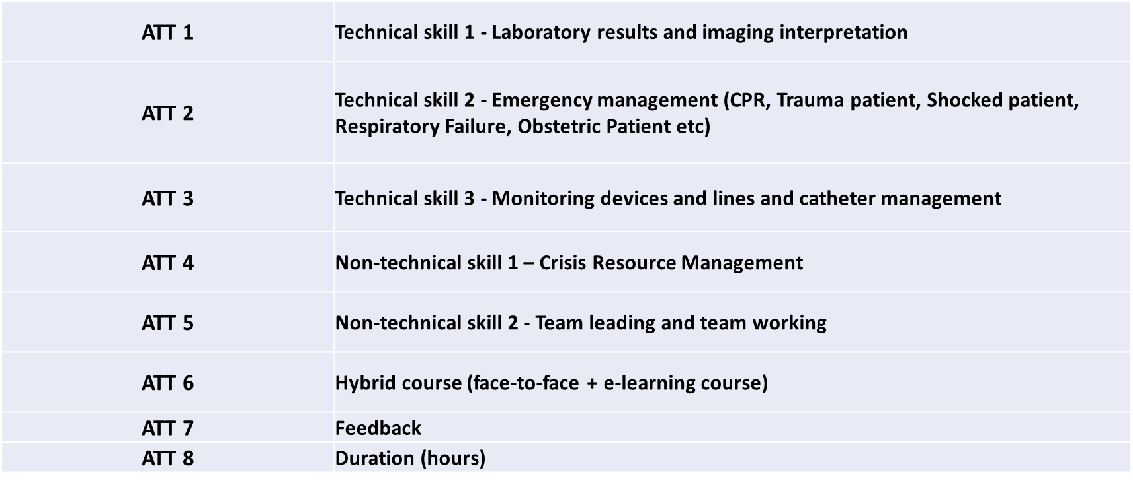
Given the good level of data collected, Gianluigi asks the partners permission to use some of the data from the training needs analysis for scientific publications focusing onsocio-economic studies, ensuring that both the partners’ names and clear references to the project will be acknowledged in the paper.
The partners will discuss internally about the common rules to adopt for publications and this point will be also included in the Agenda of the meeting in Munich on 20-21 December.
In this regard, Juan and Fedele suggest creating a group to include all the people that are willing to contribute to the papers preparation/writing and those who have been involved in carrying out the data collection. InfoTech will organize a SAFETY list of contributors for the publications, to be discussed in presence during the meeting in Munich.

Next deadlines:

- UNIFG to prepare the report on the training needs analysis by 10.11.2021.

WP2 - Presentation of the index of the Body of Knowledge (UNIFG)

At this point, Fedele (UNIFG) shows the logical framework of the Body of Knowledge that will be ready by the end of November 2021.

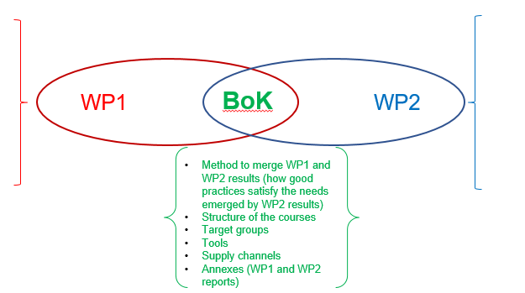

WP6 - Planning the in-person meeting in Munich (LMU + All partners)
Marc (LMU) shares his presentation, giving some information about the meeting that LMU will host in Munich on the 20th (full day) and 21st of December (until approximately 3 p.m.). The meeting will take place at Institut für Notfallmedizin und Medizinmanagement and it will also foresee a workshop session (probably the second day the meeting will end earlier than the first one, to allow the partners to leave the same day).
Marc will send a list of hotels where the partners could stay and any other logistic information for easing their travel.

Alessandro (VALUE) reminds us that, as the project follows the unit-cost system, there is no specific budget allocated for the participation and organization of project meetings. The "unit costs" system is a simplified form of determining the amount of the grant and it is a contribution to the main costs of the project which is not a reimbursement of the real expenditures linked to specific activities in the project.
The EU contribution, calculated through the unit cost, could not fully cover all expenses. It is for the beneficiary to ensure that all activities will take place as planned.
This unit cost contribution per day worked co-finances:
- All activities directly linked to the implementation of the project (project management, project meetings, production of project results, studies, dissemination, participation to events, conferences, travel, etc.);
- All costs linked to these activities (Staff cost, travel and subsistence, subcontracting, equipment and overhead costs).
The resulting EU contribution to co-finance all activities/costs of the project is represented by the “project implementation support” which is based on the following points:
- A unit cost contribution (16 separate unit staff costs - 4 groups of countries based on their respective Gross Domestic Product per capita, and to each group is allocated a unit staff cost for the 4 distinct personnel categories);
- For each work package and related activities, the partners estimated the number of staff days needed per category.
WP3 - Presentation of the overall framework for the SAFETY courses and work-plan for WP3 implementation (LMU)
Marc presents the proposal from LMU for preparing and testing the training material for e-learning theoretical and practical modules (full presentation available here). The proposed initial timeline is the following:
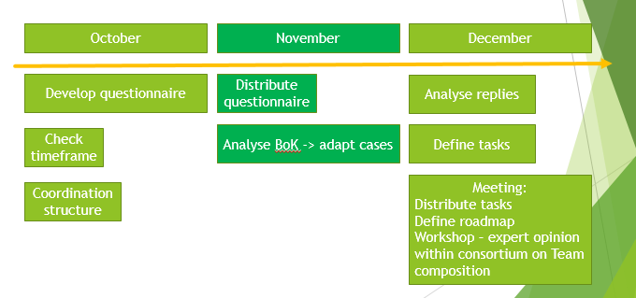
Task 1 is represented by the preparation of the materials and the definition of pedagogical criteria. In this phase, also the role of industrial partners will be stressed out. Companies will be asked to contribute by bringing their expertise and showing cases from their perspective.
Task 2 will go hand in hand with Task 4: they focus on the design of the e-learning course with theoretical modules and practical ones and the development of training materials.
In Task 3 LMU will collaborate with Evaluation Leader, EICD, to prepare the evaluation tools. Finally, based on these tools, training materials will be evaluated and refined/revised (Task 5 and 6). During the meeting in Munich, the partners will agree on the assignments for each of them within WP3 activates and they will take part in the workshop – an expert opinion on team composition.
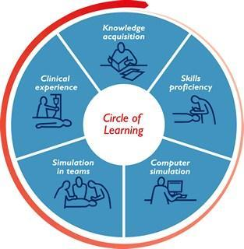
For the preparation of materials and the course in general, Marc suggests adopting a flexible approach, foreseeing flexible modules that can be adapted to different European curricula.

WP8 - Updates on the external evaluation process (EICD)

Cornelia (EICD) presents the updates on the external evaluation process (full presentation available here). She communicates to the partners that ECID, with the support of UNIFG and ValueDo, has prepared an invitation letter to send to the external evaluators that will be asked to evaluate ML3, the Body of Knowledge.
EICD will send its proposal by mail to the partners, choosing two professors among the ones that the partners suggested (the list is available here).

