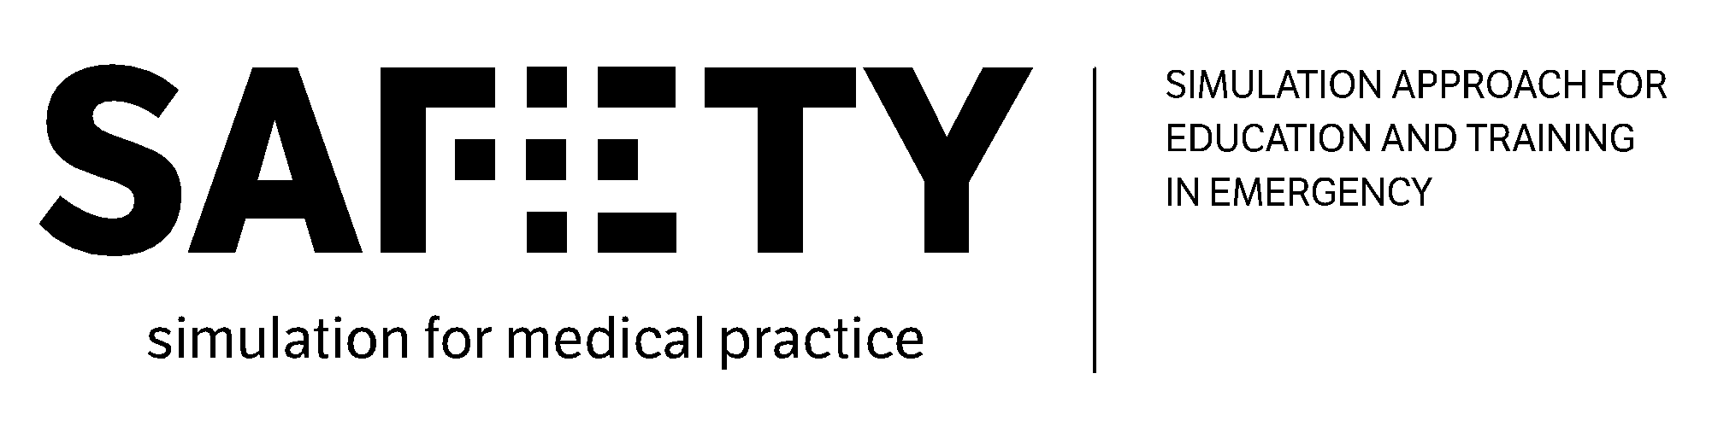
3rd official project meeting
Virtual project meeting in Munich
20-21.12.2021

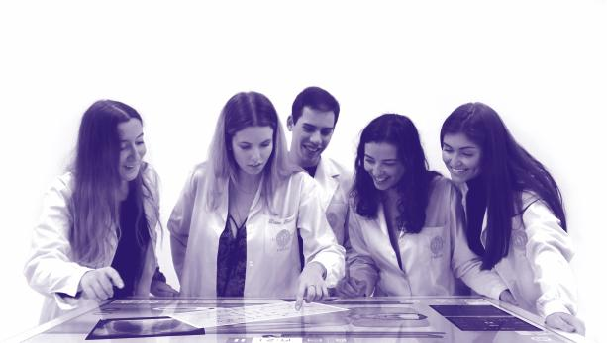
-----------------------------------------------

The European Commission's support for the production of this publication does not constitute an endorsement of the contents, which reflect the views only of the authors, and the Commission cannot be held responsible for any use which may be made of the information contained therein.

Session 1: Monday 20.12.2021 Morning
“From the BoK to the SAFETY course architecture”. Exp. Duration: 3.15 hours

Timing | Task | Responsible partner(s)
10 min  [9.20 – 9.30] | Welcome and introduction to the meeting | UNIFG + LMU
20 min  [9.30 – 9.50] | Recap on the fundamental elements from desk research, good practices and best team composition | HCB + UIS
30 min  [9.50 – 10.20] | WP2: Recap on the fundamental elements from WP2 needs analysis and BoK [starting point for the creation of the course] | UNIFG
10 min  [10.20 – 10.30] | WP3: presentation of WP3 (overall description and tasks) | LMU
30 min  [10.30 – 11.00] | Partners’ experiences based on medical education: presentation of the results of the questionnaires shared by LMU | LMU
15 min  [11.00 – 11.15] | Break
90 min  [11.15 – 12.45] | Proposal and discussion of the overall architecture of the SAFETY e-learning course | LMU

List of participants:

- University of Foggia (UNIFG) represented by Fedele Colantuono, Francesco Barberio and Roberta Caporusso;
- Hospital Clinic de Barcelona (HCB), represented by Juan Perdomo and Cristina Ibanez
- Fundació Clínic per a la Recerca Biomèdica (FCRB) represented by Sara Darriba;
- “Prof. Dr. CC. Iliescu” Emergency Institute for Cardiovascular Diseases (EICD) represented by Mihai Stefan, Cosmin Balan and Liana Valeanu;
- Ludwig-Maximilians University of Munich (LMU) represented by Marc Lazarovici and Katarina Grujic;
- University of Stavanger (UIS) represented by Thor Ole Gulsrud, Nina Vatland, Camilla Normand and Une E. Stømer;
- ValueDo (VALUE) represented by Alessandro Guadagni and Giuditta Pasta;
- Infotech (INFO) represented by Antonio Scrocco;
- Laerdal (LAE) represented by Novella Callero;
- (AMC) represented by Lukas Drabauer;
- Take the Wind (TTW) represented by Rita Flores.

Welcome and introduction to the meeting (UNIFG + LMU)
Fedele (UNIFG) and Marc (LMU) welcome the partners and present the agenda of the three sessions of the meeting. The meeting is organized in a virtual modality, but Rita (TWW) is in Munich, attending the meeting with Marc and Katarina from LMU department.
Recap on the fundamental elements from desk research, good practices and best team composition (HCB + UIS)
Juan (HCB) presents the latest version of WP1 results (the final report is available at this link: https://drive.google.com/drive/folders/1c4l51mWomAX2UxnaJyKyBr8s0RDR0642).
Juan presents the main conclusion from the desk research conducted by the University partners:
- Most of the offer came from public universities and hospitals;
- Public hospitals, public universities, and public and private simulation centres showed a statistically significant difference offer across the countries participating in SAFETY. Spain tended to have a higher number of courses offered by these institutions.
- Undergraduate nurses and physicians had the lower percentage of courses targeting them.
- Public universities showed a statistically significant tendency to have more courses targeting undergraduate physicians and nurses.
- Public hospitals showed a statistically significant trend to have fewer courses targeting undergraduate physicians and prehospital emergency staff.
- Private universities showed a statistically significant tendency to have more courses targeting nurses.
- Public and private simulation centres showed a statistically significant trend to have more courses targeting prehospital emergency staff.
- Courses related to anaesthesiology-intensive care, obstetrics, cardiology, and emergency management showed a statistically significant tendency to be more frequent in Spain.

There are few courses on patient communication, that should be addressed in WP5. The lack of courses targeting communication is due to the fact that the courses are not inter-professional.
Regarding the good practices, The Hospital Clínic collected current good practices involved in the process of planning simulation scenarios, performing prebriefing, scenarios and debriefing. Additionally, a filth subgroup of good practices related to evaluation and improvement was added. It is interesting that some good practices are referring to the importance of debriefing, which is the key point for keep patient safety and encourage simulation team to make debriefing.

WP2: Recap on the fundamental elements from WP2 needs analysis and BoK [starting point for the creation of the course] (UNIFG)
Fedele (UNIFG) recaps the process followed so far and the main evidences collected in WP2 (full presentation available here). He also explained that, due the high numbers of data on students and company needs collected, the gap analysis was taking more time than expected and a meeting among WP1 and WP2 leaders would be necessary to align all main findings. This is also influencing the development of the BoK, although its structure and content is already defined.
WP3: presentation of WP3 (overall description and tasks) (LMU)

Marc presents the next steps for WP3 development and implementation of activities. The full presentation is here.

Partners’ experiences based on medical education: presentation of the results of the questionnaires shared by LMU (LMU)

Marc (LMU) presents the results of the questionnaire LMU shared with the partners, referring to materials needed, experience in medical simulation, testing the pilot, companies support.
Referring to the materials for practical training the main results of the survey are the following:
- Full manikins for full scale simulation;
- Partial manikins for skills training (Airway Management trainer, venous and arterial, io access trainer, etc.);
- SimCapture, Vsim, SonoSim (Laerdal), iSimulate;
- VR Trainer (Body Interact, Acadicus, Immersive Interactive, OMS, SimX).
During the Europe Café the partners will go more in details on these materials for practical training.
Regarding Medical Education, the pedagogical concepts used by universities that emerged in the questionnaires are the following:
- Blended learning;
- Problem based learning;
- Team based learning;
- One-on-one and small groups teaching;
- Simulation.
The partners recommend the online course to be interactive, allowing active participation, including flipped classroom. These methodologies will be addressed more in details in Tuesday session.
Concerning the Pilot testing, the results from the questionnaire can be summarized as follows:
- Testing on residents/students in simulation center (UNIFG);
- Pilot course with students in nursing and paramedicine (UIS);
- Testing and recording (EICD);
- All-over support and product access (Body Interact).
Rita (TWW) says that is very important that the partners share among them and integrate the tools and software products they have.
Une (UIS) says that the pilot should be in cooperation with the simulation centers. Katarina (LMU) adds that if one of the university do not have a simulation center, it is possible to cooperate with simulation center made available by the partners. Une (UIS) is going to build a new building with the faculty of Stavanger and Safer (simulation center) are together.
Fedele (UNIFG) reminds that we could also involve the Associate partners in the process. If the consortium needs support from external simulation centers, it is possible to ask them to collaborate.
Francesco (UNIFG) says that the partnership could also think about the possibility of including additional simulation centers.
Proposal and discussion of the overall architecture of the SAFETY e-learning course (LMU + all partners)
The proposed architecture from LMU is the following:
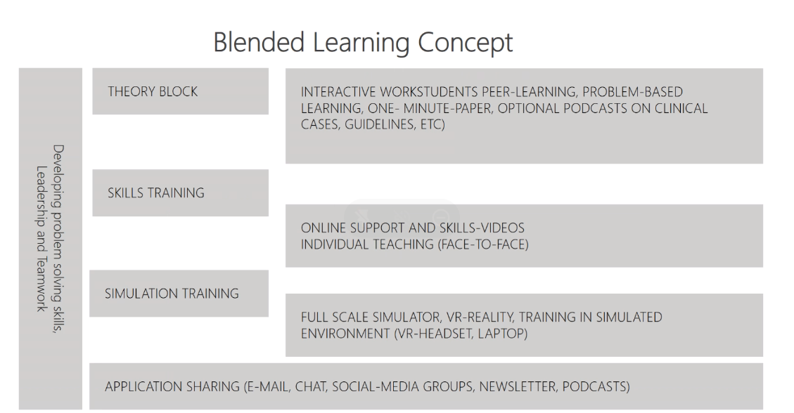
LMU proposes also to include podcasts, to be listened wherever the learners want.
The course is to be intended as an elective/optional course.
In addition to skills and training on clinical cases, LMU proposes to transfer also soft skill solving problem solving, leadership and teamwork.
The proposal is that we shouldn’t have a course longer than one semester. The format should be around this period of time, so to make it also easier to integrate into a curriculum. Cristina (HUBC) asks to keep the course as much open as possible, giving the possibility to the partners to have the different modules in more than one semester.
Camilla (UIS) and Alessandro (VALUE) stress the importance to have an idea of the number of hours that the course should last.
Marc (LMU) clarifies that the modules are not in chronological order.
LMU proposes to teach theoretic module without any specific link to the case, also because many cases would overlap. The proposal is to have just one module on emergency and then have theory skills and simulation relating to the topic.
Mihai (EICD) suggests having learning pathways according to the kind of patient. To understand which skills are needed at which point and for which specialty, the theory block should be very different for each profession and an adapting e-learning should be created, where the training offer changes according to the knowledge of each learner. The course should be flexible enough to allow to adapt the cases at each specific profession the course is addressing to.
Alessandro (VALUE) stresses out the importance to coordinate WP3 activities with WP4 tasks. He suggests organizing a meeting between the two partners responsible for these two WPs, LMU and EICD. The general suggestion is to try to keep the pilot phase short, in order not to re-distribute the tasks. The partners agree.
Alessandro (VALUE) points out that regarding the theory block, LMU is proposing flipped classroom as the methodology to use. He asks whether LMU is considering also different formats for delivering the course, such as slides on a platform and face to face training. He stresses out also that the partners need to agree and define the expected learners for the course.
Katarina (LMU) replies that the students would study alone and then will be asked to present their work during the lessons (flipped classroom methodology). The learners will be asked to interact each other, both online and in person modality. Then they also have the possibility of having simulation activities.
The partners agree that the people to be involved in the pilot course should be called learners (and not students, as some of them could not feel addressed by this definition), defined as anyone that is part of a studying-learning environment, including young PhD students.
The partners discuss about ECTS recognition, which is based on the hours that compose the total course. The course cannot take a whole semester, as it will be an extra curricula course.
Marc (LMU) proposes to postpone the decision about the number of ECTS to recognize for the learners that will take part into the pilot course when LMU will be in the middle of WP3 activities, as there they will be able to define how many hours are needed for the course. The partners will check whether their institutions are required to provide ECTS to the students.
The first session ends with the presentation from Camilla (UIS) on the fundamental elements from the desk research - best team composition (the full presentation is available here).
Camilla proposes to publish the results of desk research conducted. Marc (LMU) proposes to try to publish in the Emergency Medicine Journal. All the people that participated in the research will be authors, while all the other will be co-authors. ValueDo will circulate a Google spreadsheet with the name of the people that are authors and co-authors of the papers. On the same sheet, the partners will include a list of possible journals and conferences where to publish articles.
Camilla (UIS) proposes to go ahead with a new research and to screen other articles before conducting the publications. Alessandro (VALUE) informs the partners that this activity cannot be reported under WP1 (already concluded), so he invites the partners to report this additional research on articles under WP9, as the research aims to have a stronger impact also on exploitation and dissemination activities.

Session 2: Monday 20.12.2021
“Europe Café: brainstorming on SAFETY topics and theoretical modules”.

180 min  14.30 – 17.30 | Europe café for the proposal of possible topics of the SAFETY course – theoretical part  14.30 – 14.45: Presentation of the Europe Café methodology. Topics to be discussed in the 3 Tables:  - Emergency team composition while training  - Action to undertake by each team component according to the simulated Emergency conditions  - Simulation device for training through relevant good practices emerging from the BoK  14.45 – 15.15: First round of workshops (work group)  15.15 – 15.45: Second round of workshops (work group)  15.45 – 16.15: Third round of workshops (work group)  16.15- 16.30: Break  16.30 – 16.40: Presentation of results from Table 1 (Plenary session)  16.40 – 16.50: Presentation of results from Table 2 (Plenary session)  16.60 – 17.00: Presentation of results from Table 3 (Plenary session) | ValueDo + UniFG  - Work group (composed by representatives of HEIs and Simulation companies)  - Facilitators (UniFG, Valuedo, Infotech)

Alessandro (VALUE) welcomes the partners for the second session of the meeting and presents the guidelines for the organization and execution of Europe Café. Europe Café represents a series of discussions taking place in a relaxed, dynamic and informal environment. Europe Café revolves around the goal to discuss and exchange thoughts, questions and ideas on various topics in relation to the SAFETY e-learning course. This method ensures an effective and flexible format for hosting a series of discussions with a potentially large group of participants and can be modified to correspond to specific needs.
As the meeting is virtual, instead of talking around a table, the participants will work on Miro Board, using virtual sticky notes. Miro is the online whiteboard platform that delivers a space for all the unstructured thinking, co-creation, and visual collaboration that help innovative ideas come to life.
The participants are divided into three groups.
- Group 1: Francesco (UNIFG), Cosmin (EICD), Cristina (HUCB), Camilla (UIS), Katarina (LMU) and Lukas (AMC);
- Group 2: Liana (EICD), Juan (HUBC), Une (UIS), Marc (LMU) and Novella (LAE);
- Group 3: Roberta Caporusso (UNIFG), Mihai (EICD), Thor (UIS), Nina (UIS) and Rita (TTW).

Each group, in turn, will participate at the tables of the SAFETY café and discuss on a specific topic. The discussion will be managed by a facilitator that, at the end of the process, will briefly summarize the main insights come out from his/her table. Once a round of discussion is over, the participants are free to move to other tables.
Each participant should use sticky notes of different colours and they have at disposal 35 minutes per round: 10 minutes for self-brainstorming and 25 minutes for open discussion and clustering. The first round will last 45 minutes to let everyone get acquainted with Miro Board.
The participants should discuss the topics to be included in the specific lesson of the table, ideas on how to deliver the course, useful methodologies to be adopted and any other input for delivering the course.
The facilitators will host the sessions in different google meet rooms: groups will move from room to room at the end of each round.

The tables/boards, the links to the Google Meet room and the correspondent facilitator are the following:
- Simulation modalities and their precedence in the developed training hosted by Fedele (UNIFG)
- Prioritisation of necessary skills hosted by Giuditta (VALUE)
- Prioritisation of necessary theoretical knowledge hosted by Antonio (INFO)

The work is organized in 3 rounds:

Working tables | Round 1 | Round 2 | Round 3
Simulation modalities and their precedence in the developed training | Group 1 | Group 2 | Group 3
Prioritisation of necessary skills | Group 2 | Group 3 | Group 1
Prioritisation of necessary theoretical knowledge | Group 3 | Group 1 | Group 2

At the end of the process, the facilitators briefly summarize the main insights come out from each table. The facilitators show the Miro Boards on which all the participants have worked, trying to recap convergences and divergences.

Session 3: Tuesday 21.12.2021
“Practical aspects of the SAFETY course”

90 min  9.30 – 11.00 | Brainstorming on 25 Emergency Medicine simulations to put into practice with using simulation devices and open discussion | LMU and all partners
15 min  11.00 – 11.15 | Break
30 min  11.15 – 11.45 | Presentation and discussion of the pedagogical criteria for the e-learning course | LMU and all partners
30 min  11.45 – 12.15 | Presentation and discussion of the technical criteria for the e-learning course | LMU and all partners
30 min  12.15 – 12.45 | WP3 work plan: tasks introduction, distribution of the tasks among the partners for the preparation of training materials and deadlines | LMU and ValueDo
List of participants:

- University of Foggia (UNIFG) represented by Fedele Colantuono
- Fundació Clínic per a la Recerca Biomèdica (FCRB) represented by Juan Perdomo and Cristina Ibanez;
- “Prof. Dr. CC. Iliescu” Emergency Institute for Cardiovascular Diseases (EICD) represented by Mihai Stefan, Cosmin Balan and Cornelia Florescu;
- Ludwig-Maximilians University of Munich (LMU) represented by Marc Lazarovici and Katarina Grujic;
- University of Stavanger (UIS) represented by Thor Ole Gulsrud, Nina Vatland, Camilla Normand and Une E. Stømer;
- ValueDo (VALUE) represented by Alessandro Guadagni and Giuditta Pasta;
- Infotech (INFO) represented by Antonio Scrocco;
- Laerdal (LAE) represented by Novella Callero;
- (AMC) represented by Lukas Drabauer;
- Take the Wind (TTW) represented by Rita Flores.

Brainstorming on 25 Emergency Medicine simulations to put into practice with using simulation devices and open discussion (LMU + all partners)
Marc (LMU) starts the brainstorming on 25 Emergency Medicine simulations showing the keywords on which based them: interdisciplinary, trauma, paediatrics, shock, neurology and cardiopulmonary (full presentation available here).
The 25 Medical Simulation LMU proposes to include in the course are the following:
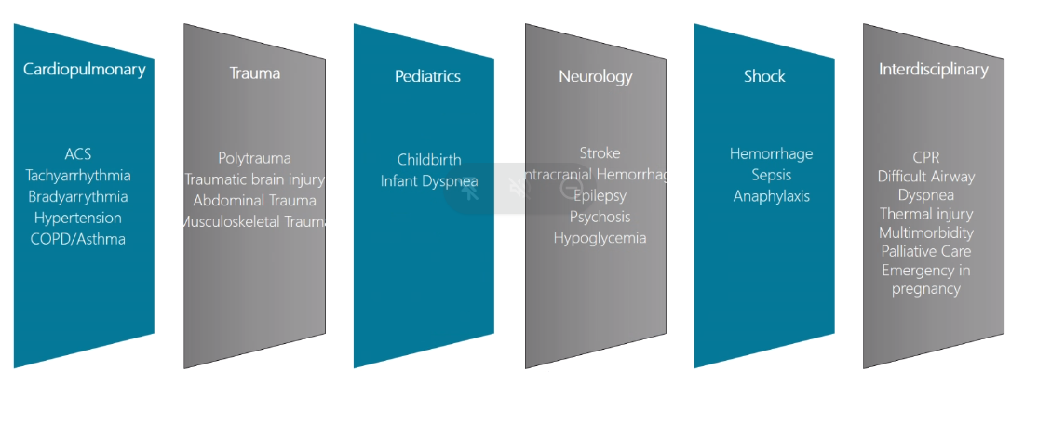
All the boxes refer to cases that are addressing both doctors and nurses or paramedics.
The partners agree to remove the interdisciplinary box and the cases inside that box will be distributed among the other boxes. Also the “pediatrics” box will be removed and replaced with another one called “Special Circumstances” that will encompass childbirth, infant dyspnea, emergency in pregnancy, thermal injury, toxicological emergencies, multimorbidity and palliative care.
The cases can be presented on virtual reality with an actor or on manikins.
The Medical Simulation should be prepared by the Academic partners, with the support of the company partners.
For preparing the cases the partners agree to involve additional associated partners.
Fedele (UNIFG) proposes to share the responsibility for preparing the cases among the partners, asking them to cherry-pick those they feel more comfortable with and have knowledge and skills for preparing. Katarina (LMU) agrees with this proposal.
Juan (HUBC) proposes to include a transversal box that specifies that not-technical skills are applying to all the boxes. It can include: teamwork, decision making, CRM.
Mihai (EICD) adds that it is useful to organize the work in pathways. He thinks that we need to stick to diagnosis; otherwise it would be too difficult to create a case to film or show in an effective way. Juan (HUBC) replies that the diagnosis shouldn’t be one of our goals, while our main goal should be to understand how to interact in a correct way with the patient.
Une (UIS) specifies that the learning goals should be multiple: they shouldn’t be the same for each case. It is useful to categorize the cases. There should be flexibility on the choice of the learning outcomes for each University preparing the cases.
Mihai (EICD) adds that from the brainstorming it emerges that we need to think for a platform that is automatic or a platform that needs a facilitator for be properly used.
Rita (TWW) points out that it is important to define a specific learning objective for each case, but it depends on the way we want to deliver it. When we are talking on virtual patient, the cases can focus on communication, collaboration etc. In this case, we can combine many thinks: for each scenario we should define the learning outcome we want to reach.
Novella (LAE) suggests that with manikins the teachers can develop manual skills, but not only those. Thanks to the possibility of including audiovisual system it will be possible to to work on the team skills, including communication skills. At the end, we can assess not only the capacity of applying protocols, but also the communication. For doing this, it is needed to have facilitators for the learning, as they can help in developing communication skills. Marc (LMU) replies that if we do manikin training we need facilitators, also for recording the experience and doing debriefing. Preparing such a training requires a lot of time from the facilitators. Novella (LAE) adds that we can maneuver manikins in an automatic mode: we need first to understand the limits that we have, such as losing the possibility of analyzing the communication skills of the students. She proposes to prepare students with a sort of e-learning and then send them in the simulation room (second part of the training). Novella proposes also to engage students for the evaluation and to include peer-to-peer methodology, to increase the capacity of the students of understanding what is going on in the simulation room.
Juan (HUBC) proposes two steps-approach:
- 1st phase: it concerns the project itself;
- 2nd phase: if the partners want to exploit the project results even after the end of the project, we need to start thinking to be more inclusive with other simulation centers and making the proposal more flexible. The cases should be flexible and be adoptable by different organizations.
Une (UIS) adds that the software UIS selects should be easy, accessible and affordable for any university in any country.
Cristina (HUBC) points out that some universities already have all these cases and they can help the centers and universities that do not have such a program. We can put an addendum in each case for using manikin or simulation. Sometimes we can have the nurse actors and the doctors as learners. Finally, the teacher or the facilitator should be able to choose to which of the targets he/she wants to deliver the cases: the cases should be flexible and adaptable to students and residents.
Novella (LAE) agrees that the cases and the training offer should be made as much flexible as possible.
The keyword is flexibility: the cases should be flexible and adaptable to the target population, they should be flexible in terms of complexity and for the goals that we are aiming to. The cases should be also flexible also for what concerns the resources and skills that the facilitators should have.
Une (UIS) suggest to LMU to include in the theoretical knowledge an introduction with the basic information on simulation, how it works and why it is needed. Marc (LMU) completely agrees on this, and he will include this introduction to simulation practice.
Marc (LMU) will share with the partners a matrix (to merge the collective wisdom of the partnership and all the ideas that came out from this brainstorming) with new cases/scenarios and boxes, with a set of questions for the partners. Afterwards, the partners will distribute the task for preparing the cases.
Main conclusions about scenarios after the brainstorming:
- Adaptive e-learning, based on profession, education level, etc.
- Educator/facilitator should be able to vary the utilisation of the scenarios based on
  - Target group
  - Learner level
  - Learning goal (e.g. more on the skill side, more decision making, etc)
  - Available resources (Manikins, Software, Task trainer, etc)
  - Usage on manikin or in computer-based VR
- Concept of Scenario overlapping through all target groups, eg. ACS treated by EMS, admitted to hospital and taking over by nurses and doctors
Next deadlines and work plan:
- LMU to send the matrix to the partners by 23.12.2021;
- Partners to fill in the matrix and send it back with comments and feedbacks to LMU by 07.01.2022.
Presentation and discussion of the pedagogical criteria for the e-learning course (LMU)

Marc starts the discussion on the pedagogical criteria for the e-learning course (full presentation available here). He asks the partners which pedagogical criteria they would like to adopt to teach the skills.
Une (UIS) replies that it is important to replace books with interactive learning to allow the learners to have an easier access to materials. She has experienced in developing course for nurses working in intensive care during covid19. She will share the e-learning course (already designed and running in Norway) about simulation. In her experience, she knows that an introduction video course on simulation was already developed in Norwegian; she shows the materials to the partners.
Alessandro (VALUE) reminds the partners that all the training materials should be delivered in English. If the partners want to translate them into other languages, they are free to do that. In the case of videos, it will be possible to include subtitles.
Alessandro (VALUE) confirms also that all the pictures included in the training materials should be free of copyright. There are many repositories that allow using pictures that are not covered by copyright or that allow to use the picture acknowledging the website form where they were taken.
LMU will include a proposal for the license to be adopted for the training materials. More information on Creative Commons can be found here: https://en.wikipedia.org/wiki/Creative_Commons_license
Next deadlines and work plan:
- LMU to summarize the inputs collected during the brainstorming by 23.12.2021;
- Partners to leave comments and additional ideas on the recap prepared by LMU by 07.01.2022.

Presentation and discussion of the technical criteria for the e-learning course (LMU)
The partners discuss about the technical criteria for the e-learning course, sharing the platforms they usually use for delivering the online courses:
- LMU uses Moodle;
- HUBC uses Moodle;
- Stavanger uses Canva;
- UniFg uses Moodle.
LMU proposes to create SCORM packages, so to make them adaptable to different platforms.
Alessandro (VALUE) explains that the templates must be clear and well defined, all the information about the font and images must be defined before starting preparing the training materials. The same applies to videos: technical criteria must be clear and agreed among the partners.
Antonio (INFO) proposes to use Google Classroom (https://classroom.google.com/h) as e-learning platform. In this platform it is possible to upload video, slides and other resources. Antonio is available to support the trainers in uploading the training materials and including the subtitles in the videos. In addition, the subscriptions to the course will be collected through the website (the same procedure already used for the subscription to the newsletter), using an enrollment form that Infotech will create. He reminds that the collaboration of Associated Partners will be very important for the launch of the course.
Partners agree to use PowerPoint for the preparation of the training materials.
Lukas (AMC) and Marc (LMU) point out that the partners should ensure that the platform selected is accessible from the hospital facilities. Antonio (INFO) will send an email to the partners to check whether there are website that cannot be reached due to firewalls. Also, he well share a link to be tested by the partners from the hospital facilities.
Alessandro (VALUE) reminds the importance of the assessment. In this kind of project we have two kinds of assessment:
- To evaluate the knowledge of the learners;
- To evaluate the quality of the training course.
About that, Camilla (UIS) proposes to use quizzes with the same questions before and after the course. This should ensure a good evaluation of the effectiveness of the course.
Alessandro (VALUE) explains that usually for this kind of projects there is an evaluation questionnaire at the end of each module: it is valuable to have different evaluations as there are a lot of skills and it is important to evaluate them differently.
Next deadlines and work plan:
- All the university partners will verify if there are restrictions or limitations to access google classroom in January 2022
- Infotech will send the test on Google classroom by 07.01.2022
- Infotech to prepare some guidelines for LMU on technical criteria for the course by 07.01.2022
WP3 work plan: tasks introduction, distribution of the tasks among the partners for the preparation of training materials and deadlines (LMU + ValueDo)
Alessandro (VALUE) shows the next deadlines for WP3 activities:
- LMU to share the matrix for collecting information form partners on Simulation cases by 23.12.2021
- Partners to fill in the matrix shared by LMU by 06.01.2022
- LMU to summarize the inputs collected during the brainstorming about pedagogical criteria by 23.12.2021.
- Partners to leave comments and additional ideas on the recap prepared by LMU by 06.01.2022
- LMU to prepare the first version of the R3.1 Action Plan for the e-learning course (both theoretical and practical modules) by 31.01.2022
- All the partners to revise the first version of the R3.1 Action Plan for the e-learning course (both theoretical and practical modules) by 11.02.2022
- LMU to deliver the final version of the R3.1 Action Plan for the e-learning course (both theoretical and practical modules) by 18.02.2022. This deadline could be extended in case of needs.

