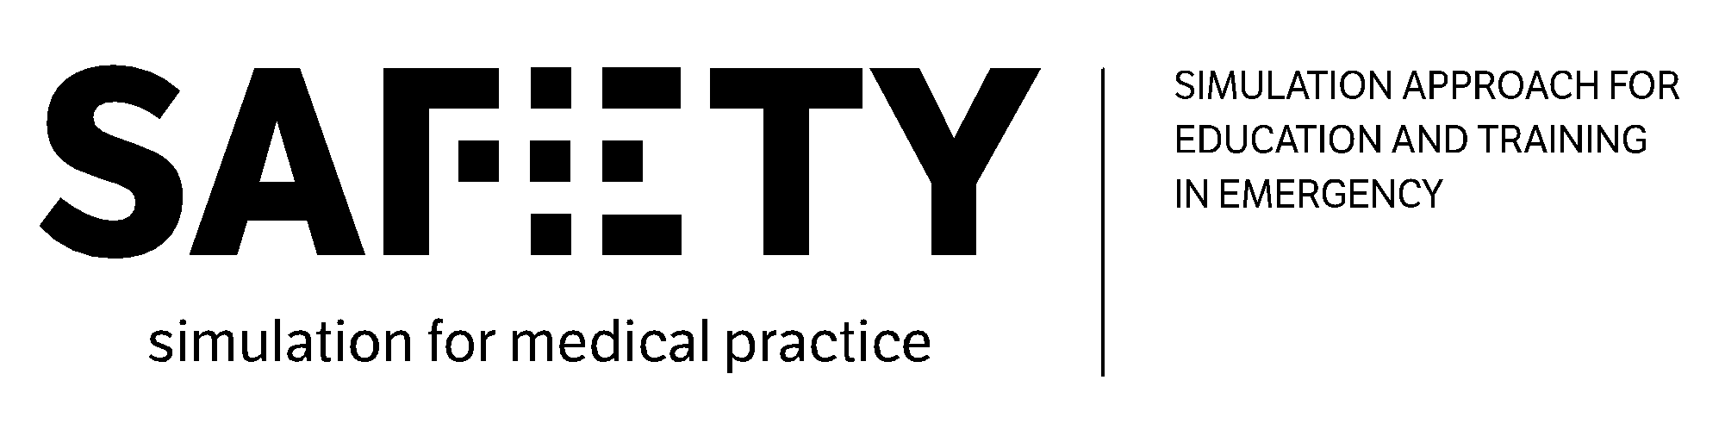

SAFETY - Simulation Approach For Education and Training in emergencY
621605-EPP-1-2020-1-IT-EPPKA2-KA

Virtual Project meeting in Munich

Session 1: Monday 20.12.2021 Morning
“From the BoK to the SAFETY course architecture”. Exp. Duration: 3.15 hours

10 min  [9.20 – 9.30] | Welcome and introduction to the meeting | UNIFG + LMU
20 min  [9.30 – 9.50] | Recap on the fundamental elements from desk research, good practices and best team composition | HCB + UIS
30 min  [9.50 – 10.20] | WP2: Recap on the fundamental elements from WP2 needs analysis and BoK [starting point for the creation of the course] | UNIFG
10 min  [10.20 – 10.30] | WP3: presentation of WP3 (overall description and tasks) | LMU
30 min  [10.30 – 11.00] | Partners’ experiences based on medical education: presentation of the results of the questionnaires shared by LMU | LMU
15 min  [11.00 – 11.15] | Break
90 min  [11.15 – 12.45] | Proposal and discussion of the overall architecture of the SAFETY e-learning course | LMU

Session 2: Monday 20.12.2021 Afternoon
“Europe Café: brainstorming on SAFETY topics and theoretical modules”. Exp. Duration: 3 hours

180 min  14.30 – 17.30 | Europe café for the proposal of possible topics of the SAFETY course – theoretical part  14.30 – 14.45: Presentation of the Europe Café methodology. Topics to be discussed in the 3 Tables:  - Simulation modalities and their precedence in the developed training  - Prioritisation of necessary skills  - Prioritisation of necessary theoretical knowledge  14.45 – 15.30: First round of workshops (work group)  15.30 – 16.05: Second round of workshops (work group)  16.05 – 16.40: Third round of workshops (work group)  16.40- 16.50: Break  16.50 – 17.20: Presentation of results from the three tables (Plenary session) | ValueDo + UniFG  - Work group (composed by representatives of HEIs and Simulation companies)  - Facilitators (UniFG, Valuedo, Infotech)

Session 3: Tuesday 21.12.2021 Morning
“Practical aspects of the SAFETY course”. Exp. Duration: 3 hours

90 min  9.30 – 11.00 | Brainstorming on 25 Emergency Medicine simulations to put into practice with using simulation devices and open discussion | LMU and all partners
15 min  11.00 – 11.15 | Break
30 min  11.15 – 11.45 | Presentation and discussion of the pedagogical criteria for the e-learning course | LMU and all partners
30 min  11.45 – 12.15 | Presentation and discussion of the technical criteria for the e-learning course | LMU and all partners
30 min  12.15 – 12.45 | WP3 work plan: tasks introduction, distribution of the tasks among the partners for the preparation of training materials and deadlines | LMU and ValueDo

