Knowledge Alliance

“SAFETY - Simulation Approach For Education and Training in emergencY”
621605-EPP-1-2020-1-IT-EPPKA2-KA

2nd official project meeting “Barcelona”
5th May 2021
The second official project meeting, foreesen on month 6, was performed online instead of Barcelona as originally indicated in the proposal, due to the Covid-19 pandemic difficulties to travel and have open events.
The meeting agenda was the following:
- WP1: Desk research - updates (FCRB);
- WP1: Literature review - updates (UIS);
- WP1: First brainstorming on R1.4 - document aims and structure (FCRB and UIS);
- WP6: Brief recap on administrative and financial procedures (UNIFG and ValueDo);
- WP8: Planning external evaluation by experts on ML1 Training needs assessment (EICD);
- WP9: Updates on dissemination activities (InfoTech);
- WP2: Updates on the survey results (UNIFG);
- WP2: First brainstorming on R2.3 - document aims and structure (UNIFG).

and almost all partners were represented in the meeting, as in the following list of participants, with the exception of ACM, not able to take part:

- University of Foggia (UNIFG) represented by Fedele Colantuono, Francesco Barberio, Roberta Caporusso and Giacomo Errico;
- Fundació Clínic per a la Recerca Biomèdica (FCRB) represented by Carlos Ferrando and Juan Perdomo, Beatriz Tena;
- “Prof. Dr. CC. Iliescu” Emergency Institute for Cardiovascular Diseases (EICD) represented by Daniela Filipescu, Mihai Stefan, Cornelia Florescu and Liana Valeanu;
- Ludwig-Maximilians University of Munich (LMU) represented by Marc Lazarovici;
- University of Stavanger (UIS) represented by Thor Ole Gulsrud, Nina Vatland, Camilla Normand and Une E. Stømer, Peter Dieckmann
- ValueDo (VALUE) represented by Giuditta Pasta;
- Infotech (INFO) represented by Antonio Scrocco;
- Laerdal (LAE) represented by Luigi Danesi;
- Take the Wind (TTW) represented by Pedro Pinto, Rita Flores and Silverio Mendes.

WP1: Desk research - updates (FCRB)
Juan (FCRB) starts presenting the updates of the desk research carried out (full presentation available here). The Final action plan after the pilot has been sent to the partners at the end of March 2021; then, at the beginning of April, all the collaborators were given access to RedCap and a brief tutorial video has been presented to them.
At the moment all the partners are updating the information about the desk research on RedCap. Juan reminds the partners to keep uploading the information they are collecting on RedCap. The university partners will contact the partner companies to collect their best practices.
Camilla (UiS) asks Juan how many entries he expects to reach for each country. He replies that there is not a specific target for hospitals/universities to be reached.
Fedele (UNIFG) asks for an overview of the collection of data among countries. He thinks that it would be very useful to have specific information from each partner country. This aspect is also highlighted by Carlos Ferrando, reminding all partners to perform the desk research.
Marc (LMU) adds that LMU team has researched, and is researching, the information not only on the official websites, but they are considering also the social media channels and a google search.
Juan (FCRB) replies that the majority of information gathered by FCRB come from the official websites of the universities and hospitals. They found also some extra information from Google and very little ones from social media channels.
Roberta (UNIFG) adds that the information gathered from UNIFG team come from universities’ websites (but also social channels). Roberta, as Italian representatives of medicine residents, has contacted directly colleagues from other universities that she already knew. According to her experience, on the official website of universities and simulation centres there are a lot of information, so it has been quite easy to carry out the research.
Mihai (EICD) informs the partners that EICD team has not started yet to upload the findings on RedCap. He personally knows that some universities actually do simulation, but there is not any information about it on their official websites.
Juan (FCRB) specifies that the target is not only “simulation offer”, but “emergency offer”. It is not compulsory to contact directly people from universities or simulation centres and go beyond their official websites if some information are not available there. The consortium can guarantee that all the information gathered in RedCap are reliable.
Next deadlines and workflow:
- All the University partners’ information available on RedCap by 07.07.2021.

WP1: Literature review - updates (UIS)
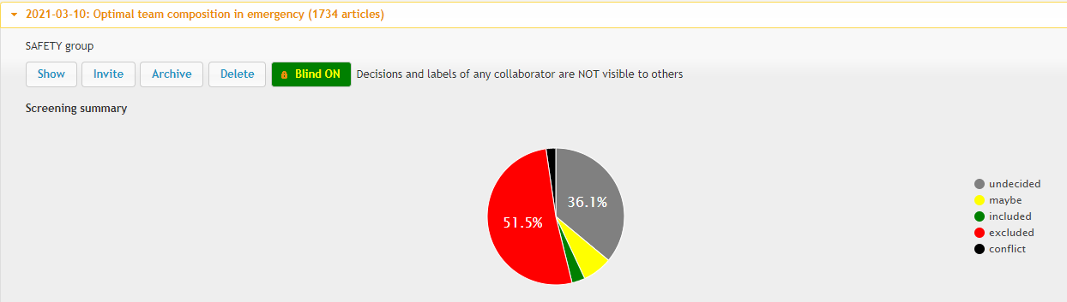
Camilla (UiS) updates the partners about the literature review process of WP1 (full presentation available here). UiS has finalized the inclusion and exclusion criteria to be used for the search strategy. 1734 results have been exported to Rayyan, while 19 participants were involved in the initial screening (the work has been organized as a double screening).

The remaining actions to carry out are:
- Organization of group meeting to discuss how to deal with discrepancies;
- Organization of meeting between 2 screeners to discuss discrepancies;
- Organization of group meeting to discuss full-text screening;
- Full-text screening;
- Creation of a Folder of scientific literature on optimal team composition in emergency;
- Organization of group meeting to discuss report writing;
- Writing the report.
Next deadlines and workflow:
- UiS to complete the initial exclusion of articles by 31.05.2021;
- UiS to deliver the report on in-depth literature review on team composition in emergency by 31.07.2021.
WP6: Brief recap on administrative and financial procedures (UNIFG and ValueDo)
Fedele (UNIFG) makes a short recap on administrative and financial activities of the project performed so far (full presentation available here). He reminds the partners about deadline to present the financial documents for the second quarter (February – April 2021): 10th May 2021.
Finally, Fedele informs the partners that an amendment to project consortium occurred. The partner Hospital Clinic de Barcelona has been replaced by Fundació Clínic per la Recerca Biomèdica, but it remains as affiliate partner in the project, being responsible for the same WPs and duties as from the beginning. The request was sent officially to the EACEA on 17/02/2021 and approved on 16/03/2021.
Giuditta (VALUE) briefly recaps the steps for the quality assurance. All the partners should complete the Google Spreadsheet at the following link:
https://docs.google.com/spreadsheets/d/1A84eKycwFfFBZ1HyizXFsRFHpnUoUj81g1AllVCSDMo/edit#gid=0 within the information about the second quarter of SAFETY project (February - April 2021). The first to complete the spreadsheet must be the Lead Partners (10.05.2021), all the others will follow (by 14.05.2021). Giuditta reminds the partners that the procedure to follow for the completion of the quarterly report is described in the Quality Assurance Plan, available here.
WP8: Planning external evaluation by experts on ML1 Training need assessment (EICD)
Cornelia (EICD) starts presenting the plan they have prepared for the external evaluation from experts on ML1 Training need assessment (full presentation here). Cornelia explains that the partners should select at least 6 external evaluators (2 per each ML to be evaluated: ML1, ML2 and ML6). It was then discussed and agreed among the partners that the external experts will have to know the field of Simulation for Emergency Medicine and they should come from heterogeneous professional fields (academics, private consultants, policy makers).
Cornelia (EICD) proposes the following strategy to implement:
- Preparation of a list of experts with the contribution of all partners that will look like this one:
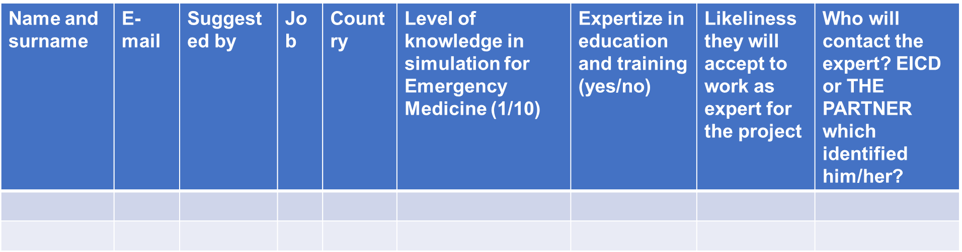
- EICD should prepare an invitation letter to inform the experts about the request and the effort asked to them;
- Preparation of semi-structured interview by EICD, in agreement with UniFg and ValueDo (as prepared for T 8.1);
- Delivery of an evaluation report based on the feedback collected from the experts.
As the first two MLs to be evaluated belong to WP1 and WP2, EICD expects to be supported mainly by the leaders of these WPs for the preparation of the questions. All the partners agree on the approach and deadlines proposed by EICD.
Next deadlines and workflow:
- Partners to fill the excel file created by EICD with the names and all the other information indicated for the external experts by 15.09.2021;
- EICD to prepare a draft of the semi structured survey by 30.09.2021;
- EICD to collect feedback / approvals to run the MLs assessment by the beginning of November 2021;
- Depending on the decisions, approach to the external reviewers will be carried out during November – December 2021, establishing the right time window for the interview.
WP9: Updates on dissemination activities (InfoTech)
Antonio (INFO) presents the main updates on dissemination activities. The full presentation is available here. In the coming months also the YouTube channel of the project will be online.
Antonio explains that in the YouTube channel of SAFETY project, he will upload video on simulation in emergency medicine and he will ask the partners to record a short video about their experience and work-strategy, to create our visual identity in the most efficient way. Furthermore, when the project will produce its main results, Antonio will present them in short videos that will be uploaded on YouTube.
Pedro (TWW) adds that Take The Wind participates and organizes many webinars, also involving companies outside Europe (the video of their last webinar is available here: https://vimeo.com/544499237/821c1c196f). Antonio (INFO) adds that it could be a good idea to invite some representatives of SAFETY to take part in these webinars to present the project. This kind of events is really important for the dissemination and promotion of our project.
Pedro will update Antonio with the agenda of the next event.
Francesco (UNIFG) informs the partners that in June 2021 in Italy, SIMMED, the Italian society of simulation in medicine will organize its national congress. SIMMED invites UNIFG to participate with a brief presentation of SAFETY project.
Marc (LMU) adds that also in September/October there will be an event of the German society of simulation in medicine. He will inform the partners about his possibility to participate and present SAFETY.
Fedele reminds all participants that these events are really important for the project dissemination and visibility, and that everyone undertaking these initiatives has to inform periodically Antonio, also posting news for the SAFETY website and keep track for the dissemination report.
WP2: Updates on the survey results (UNIFG)
Francesco (UNIFG) presents the updates on the survey results and Fedele gives an update about the Companies’ needs survey development (full presentation here).
Francesco reminds the expected target to reach:
- At least 500 students from each country involved in the project;
- At least 100 academics from each country involved in the project.
At the moment the numbers reached by each country are the following:
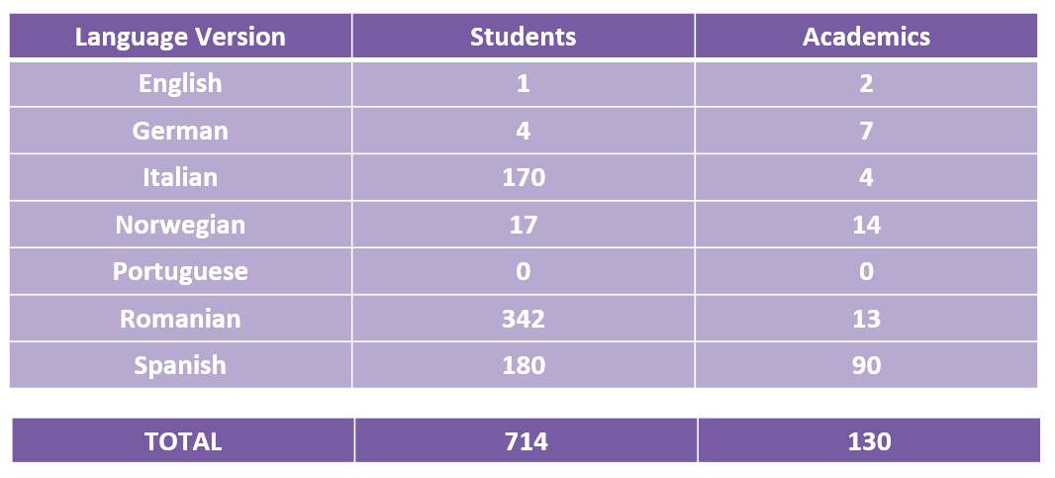
UNIFG shared the methodology adopted to disseminate as much as possible the surveys:
- Through Official Channels
  - SAFETY website and social
  - ‘Skill Lab’ UniFg page on Facebook
  - Invitation through University Mailing-lists for Students and Academics
  - UniFg students association
  - EACEA common platform with other Erasmus+ KA projects
  - Involving new associated partners
    - SISM , IFMSA (International Federation of Medical Students’ Associations)
    - CeSi Lugano (doc. Pier Luigi Ingrassia)
    - Request sent to SIMMED (Italian Simulation Society)

- Un-official Channels
  - Whatsapp contacts
    - UNIFG has direct contacts with Rome, Milan and Padova
Fedele (UNIFG) asks the other partner Universities how they think to improve their numbers, especially LMU and UiS as Germany and Norway have the lower numbers, since TTW was going to spread the surveys through their national and international networks.
- LMU; Marc (LMU) specifies that the low results have nothing to do with the pandemic. We have also submitted the surveys through our social media channels. The result is very weak, people probably feel completing the questionnaire as an intrusion. To get more convincing results, Marc will go through student organizations and contact academics directly. Marc (LMU) asks if it is preferable to rely more on personal contacts than on official contacts of the institutions. Francesco (UNIFG) replies that he personally contacted professors who subsequently proved to be very interested in filling out the survey. This methodology has been effective, as this personal contact allowed the activation of a number of other contacts. Francesco suggests Marc to publish the surveys on SESAM channels.

- UNIFG; Francesco (UNIFG) agrees with Marc, because also UNIFG experienced the same problems with academic surveys (they received only 4 responses from UNIFG). UNIFG is evaluating the possibility to send the invitation to academics through the mailing lists of anaesthesia professors in Italy. Concerning the surveys for the students, UNIFG is contacting many student organizations, especially at the University of Padua which is increasing its simulation centre.

- UiS; Une (UiS) agrees with Marc that people can feel the receipt of these messages as an intrusion, often receiving requests to fill out surveys can be cumbersome and people directly trash the email without paying much attention to the content of the questions. Une specifies that she has followed the official channels to contact people, but based on UNIFG's suggestions she will try to adopt less institutional communication channels and prefer personal contacts.

- EICD; Liana (EICD) explains that although all courses are still taught in online mode, probably the high number of reached students (342) is due to the fact that simulation in emergency medicine is a new topic in Romania and they are very interested to it.

- FCRB; Juan (FCRB) adds that 180 Spanish students were reached through the surveys. FCRB only used official channels to contact them (but students were asked to send surveys via WhatsApp to other students) and sharing a presentation of the SAFETY project with the University's department heads explains the good number of academics replies .
Francesco and Fedele proposed to share the letter sent by UNIFG with the partners, to allow them to use it as a template and translate in their national language. Antonio (INFO) will send an English and editable version to all partners.
Francesco proposes to postpone the deadline to conclude the surveys from 31.05.2021 to 15.06.2021 to try to have more replies and have a robust statistical analysis. All partners agree.
New deadlines and workflow:
- All University partners to collect all data from the surveys by 15.06.2021.
- Complete the pilot test and have a definitive version for the Companies’ survey by middle of May 2021.
- Perform the Companies’s needs survey between May and June 2021.


