External Experts Evaluation Report ML6

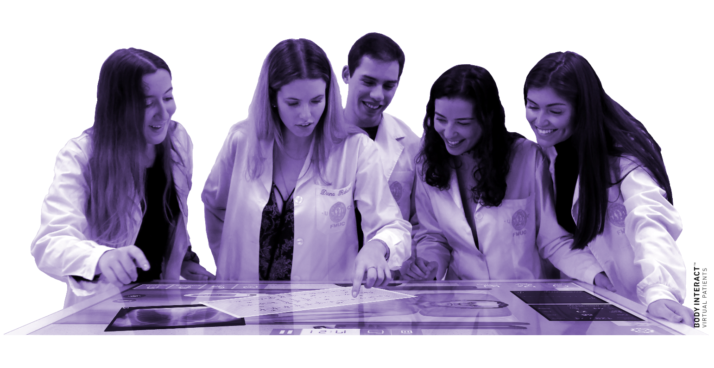

-----------------------------------------------
The European Commission's support for the production of this publication does not constitute an endorsement of the contents, which reflect the views only of the authors, and the Commission cannot be held responsible for any use which may be made of the information contained therein.

DOCUMENT VERSION 01
--------------------------------------

AUTHORS
--------------------------------------
Cornelia-Elena Predoi, EICD

Mihai Stefan, EICD

Liana Valeanu, EICD

Cosmin Balan, EICD

Cornel Robu, EICD

Serban Bubenek Turconi, EICD

Daniela Filipescu, EICD

External Evaluation

In this section, we will present the experts selection process (from the action plan for external evaluation and the selection criteria to the presentation of the evaluation questionnaires of ML 6) that led us to contact two external evaluators in order to assess the work performed in WP4 and WP5. We will also present a summary of the experts’ evaluation questionnaire results.

Action plan for external evaluation
The survey action plan for external evaluation was based upon Quality Assurance Plan and the SAFETY detailed project description. Objectives, expected results and evaluation indicators of each ML to be subjected to external evaluation are briefly explained, to experts’ guidance through the evaluation process. We did this by using an invitation e-mail. To evaluate the MLs, a specific questionnaire was elaborated. Some questions, focused on the main priorities were proposed.
At this point of the project execution, WP4 and WP 5 are concluded and after partners’ revision they were sent to the experts for evaluation.
External experts selection criteria
- The Milestone expected results concern the evaluation of the moodle platfom of the SAFETY Project which contains the theoretical modules which – consist of 10 hours at least distributed in 2 hours at least per each university partner (5 sub modules). It will deal with theoretical aspects of a) Emergency team composition while training; b) action to undertake by each team component according to the simulated Emergency conditions; c) simulation device for training through relevant good practices emerging from the Body of Knowledge (e.g how to improve the efficacy of training to better replicate real situation with simulation) and the practical modules which consist of: 39 different Emergency Medicine situations replicated into the simulation room. The simulation consists of a practical action in the simulation room and final discussion between the team members. All simulations are recorded and constitute part of the e-learning course.

Therefore, the following criteria were addressed to select the three evaluators from the proposed ones:

- will have to know the field of Simulation for Emergency Medicine
- evaluators come from heterogeneous professional fields (academics, private consultants, policy makers)
- collecting the feedback on the same milestone by experts coming from different fields
The partners were asked to recommend some names in the MLs’ area of knowledge. Those experts were presented to the Steering Committee and two for each ML were selected and invited to perform the evaluation.

Selected experts
The selected experts were:
1.Prof. Savino Spadaro from the Simulation centre University of Ferrara, Italy.
2. Gottschalk Johannes from the Bayerisches Rotes Kreuz Kreisverband Regensburg
3. Antonia Hofmann from the Technische Hochschule Deggendor.
4. Prof Stefania Brusa from the Simulation Centre Humanitas, University of Milano, Italy
5. Lukas Safranek from the Technische Hochschule Deggendor.

Prof. Savino Spadaro is currently a Researcher of Anesthesia and Intensive Care with the University of Ferrara, Italy. He has been involved in several research project in Critical Care Research since 2013. He is one of the certified Instructor of Simulation with the Center of Ferrara. His current focus is on mechanical ventilation and ultrasound simulation, with a research interest in the respiratory medicine and medical education in Italy.

Gottschalk Johannes from the Bayerisches Rotes Kreuz Kreisverband Regensburg has a great experience in simulation, between 5 and 10 years. His expertise in this field is internationally recognized.

Antonia Hofmann obtained her Bachelor’s degree in Biology at Goethe University in Frankfurt am Main. After graduating in 2015 she started studying Marine Biology at the University of Rostock and received her Master’s degree. In May 2018, Antonia joined the Dikic group as a Technical Assistant to support the group.

Prof. Stefania Brusa it is the scientific coordinator of the Centro di Simulazione Humanitas University presso Humanitas University, Italy with a vast experience in simulation. She is also the chief of the Dipartimento Anestesia e Rianimazione Istituto Clinico Humanitas, adjunct Teaching and Clinical Professor Humanitas University, Coordinator Sezione Simulazione SIAARTI and ,ember comitato formazione SIAARTI.

Lukas Safranek from the Technische Hochschule Deggendor has a 1 to 5 year experience is simulation.

External evaluation results
In this section a summary of the experts’ evaluation questionnaire results is presented. For further details, the completed questionnaires are attached to this report.
External evaluation of ML 6
Modules watched on the platform
Module 1 – An introduction to medical simulation was watched by 3 experts, Module 2 – Cardiovascular Emergencies was watched by 2 experts, Module 3 – Shock was watched by 3 experts, Module 4 – Pulmonary Emergencies was watched by 2 experts, Module 5 – Traumatic Emergencies was watched by 2 experts, Module 6 – Neurologic and Psychiatric Emergencies was not watched, Module 7 – Thermal and toxicological emergencies was watched by 1 expert, Module 8 – Infant Emergencies and Obstetrics was watched by 1 expert, Module 9 – Systematic Approach to Emergency was watched by 3 experts, Module 10 – Aspects of CRM, Teamwork, Leadership, Communication was watched by 2 experts.
The overall educational experience of the course
4 experts rated the overall education experience of the course 4 points out of 5 and 2 of them 5 points out of 5.
The overall design of the platform
1 expert rated the overall design of the platform 3 points out of 5, 1 rated 4 point out of 5 and 3 experts rated 5 points out of 5.
The ease of navigation on the platform
1 expert rated the ease of navigation on the platform 4 points out of 5 and 4 experts rated it 5 points out of 5.
Accesibility of the course materials
2 experts rated the accesibility of the course materials 4 points out of 5, and 3 experts rated it 5 points out of 5. One expert consider that it would be nice if the completed button was activated automatically, if technically possible (like in a H5P).
Organisation of the course materials
1 experts rates the organisation of the course materials 3 points out of 5, 1 experts rates it 4 points out of 5 and 2 experts rate it 5 points out of 5. One experts consider that if the beginning and end of each lesson is the same and includes a written summary, this supports recognizability.
Engagement features of the courses
3 experts rate the engagement features of the courses 4 points out of 5 annd 2 of them rate it 5 points out of 5.
Platform's responsiveness
1 expert rated the platform’s responsiveness 3 points out of 5 and 4 of them rate it 5 points out of 5.
Technical issues while using the platform
4 experts do not have technical issues while using the patform, but one related that he had some issues regarding the virtual patient: often delayed reactions. The measuring devices for example didn't disappear from the screen after using them. The handling of the "commands" was really complicated, confusing list, long searching. practical scenarios: sometimes problems with the sound. He couldn't understand people, but background noises were often very loud, but not in every video.
Recommendation of the e-learning platform to others
1 experts would recommend the e-learning platform to others 6 points out of 10, 2 experts will recomment it 9 points out of 10 and 2 experts will recommend it 10 points out of 10.
Improvements or additional features for the platform
One experts suggests to increase the difficulties of case scenario that required advanced monitoring and useful to interpret appropriately the results of advanced haemodynamic and respiratory monitoring.
Another experts has the opionion that a short written introduction to each module would be a good addition, another that after clinical scenario at the end of debriefing it could be useful to have a declared and shared take home message and a forth that the videos should be more interactive.
Comments or suggestions for enhancing the user experience
One expert thinks that overall the platform is an excellent instrument and it well done. It is to navigate in the platform and he thinks that will be interesting to share it with students, residents and other doctors not involved in the emergencies field. He thinks that should be integrated with advanced cases and issue in the future steps.
Another expert suggests that a short summary in practical scenarios would be good. The debriefings take a long time and there is no overview of what they did good or not so good and what they could have done better. Or maybe a sample solution for the case after the video or in the course. Transcript is definitely necessary.
A third opinion is that it is a really detailed theoretical input. The expert does not know if he would watch every single minute of every video. But if it is meant to refresh knowledge about the different themes/cases or to deepen knowledge, with the option to skip parts of the videos, it is ok. Maybe some "topic markers" would be good. So you can jump to parts of interest in the videos without searching.

ANNEX 1 - Results of the evaluation questionnaires of ML 6

