Students External Evaluation Report ML6

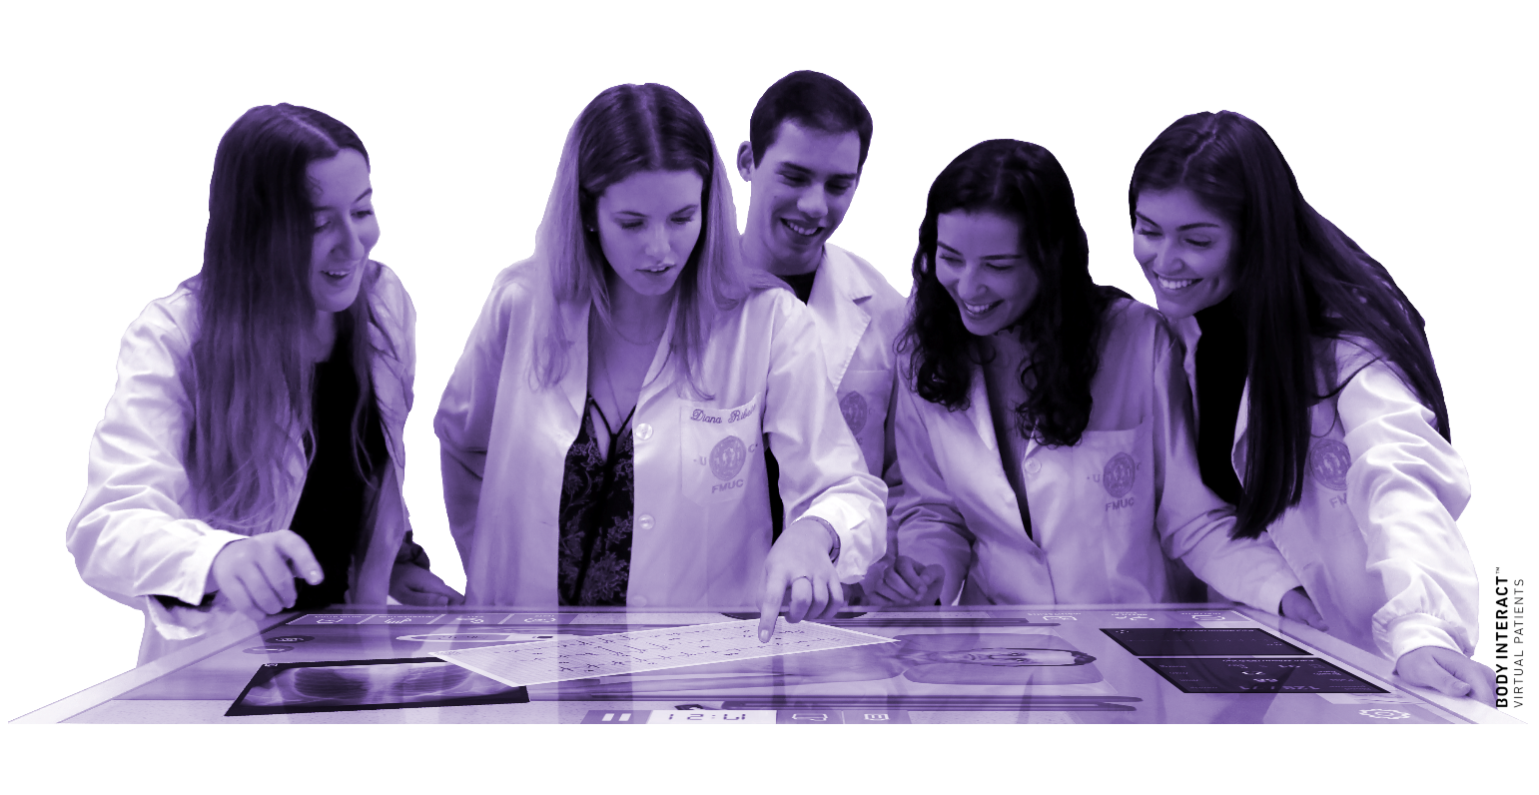

-----------------------------------------------
The European Commission's support for the production of this publication does not constitute an endorsement of the contents, which reflect the views only of the authors, and the Commission cannot be held responsible for any use which may be made of the information contained therein.

DOCUMENT VERSION 01
--------------------------------------

AUTHORS
--------------------------------------
Cornelia-Elena Predoi, EICD

Mihai Stefan, EICD

Liana Valeanu, EICD

Cosmin Balan, EICD

Cornel Robu, EICD

Serban Bubenek Turconi, EICD

Daniela Filipescu, EICD

External Evaluation

In this section, we will present the experts selection process (from the action plan for external evaluation and the selection criteria to the presentation of the evaluation questionnaires of ML 6) that led us to contact two external evaluators in order to assess the work performed in WP4 and WP5. We will also present a summary of the experts’ evaluation questionnaire results.

Action plan for external evaluation
The survey action plan for external evaluation was based upon Quality Assurance Plan and the SAFETY detailed project description. Objectives, expected results and evaluation indicators of each ML to be subjected to external evaluation are briefly explained, to experts’ guidance through the evaluation process. We did this by using an invitation e-mail. To evaluate the MLs, a specific questionnaire was elaborated. Some questions, focused on the main priorities were proposed.
At this point of the project execution, WP4 and WP 5 are concluded and after partners’ revision they were sent to the experts for evaluation.
External students selection criteria
- The Milestone expected results concern the evaluation of the moodle platfom of the SAFETY Project which contains the theoretical modules which – consist of 10 hours at least distributed in 2 hours at least per each university partner (5 sub modules). It will deal with theoretical aspects of a) Emergency team composition while training; b) action to undertake by each team component according to the simulated Emergency conditions; c) simulation device for training through relevant good practices emerging from the Body of Knowledge (e.g how to improve the efficacy of training to better replicate real situation with simulation) and the practical modules which consist of: 39 different Emergency Medicine situations replicated into the simulation room. The simulation consists of a practical action in the simulation room and final discussion between the team members. All simulations are recorded and constitute part of the e-learning course.

Therefore, the following criteria were addressed to select the 40 students evaluators:
  - Between 8 to 10 students selected by each University (5 Partners )
  - The students had to be external from the SAFETY Project (not the ones involved in filming the scenarios)

Selected students evaluators
The selected students were:
1. 4 students from University of Ferrara (selected by University of Foggia).
2. 1 student from Nostra Signora del Buon Consiglio (selected by University of Foggia).
3. 1 student from University UniCamillus (selected by University of Foggia).
4. 4 students from the Bayerisches Rotes Kreuz Kreisverband Regensburg (selected by University of Munchen).
5. 1 student from the University of Karadeniz (selected by University of Munchen)
6. 1 student from the University of Masaryk (selected by University of Munchen)
7. 11 students from the University of Medicine “Carol Davila”, Bucharest (selected by EICD)
8. 8 students from the University of Stavanger (selected by University of Stavanger)
9. 3 students from the University of Valencia (selected by University of Barcelona)
10. 1 student from the University Santiago de Compostela (selected by University of Barcelona)

External students’ evaluation results
In this section a summary of the students’ evaluation questionnaire results is presented. For further details, the completed questionnaires are attached to this report.
External evaluation of ML 6
Modules watched on the platform
Module 1 – An introduction to medical simulation was watched by 21 students, Module 2 – Cardiovascular Emergencies was watched by 21 students, Module 3 – Shock was watched by 16 students , Module 4 – Pulmonary Emergencies was watched by 12 students, Module 5 – Traumatic Emergencies was watched by 13 students, Module 6 – Neurologic and Psychiatric Emergencies was watched by 12 students, Module 7 – Thermal and toxicological emergencies was watched by 7 students, Module 8 – Infant Emergencies and Obstetrics was watched by 8 students, Module 9 – Systematic Approach to Emergency was watched by 8 students, Module 10 – Aspects of CRM, Teamwork, Leadership, Communication was watched by 5 students.
The overall educational experience of the course
1 student rated the overall education experience of the course 2 points out of 5, 7 of them rated 3 points out of 5, 11 students rated 4 points out of 5 and 16 students rated it 5 points out of 5.
The overall design of the platform
1 student rated the overall design of the platform 1 point out of 5, 1 rated 2 points out of 5, 15 students rated 4 points out of 5 and 18 students rated it 5 points out of 5. One student thinks that because only english language is available, might be difficult to navigate for certain audiences. Another student thinks that there are a bit too many modules and links to click on. Also the "Body interact" did not work, the site did not answer when accessed by one student.
The ease of navigation on the platform
1 student rated the ease of navigation on the platform 1 point out of 5, 4 students rated it 3 points out of 5, 14 students rated it 4 points out of 5 and 16 students rated it 5 points out of 5. One students says that in order to enroll in a new course, he has to press the "Home" button, and that doesn't seem very intuitive to him. He would suggest an additional button in the top bar next to "My courses", a button with "Available courses". Another student suggests that it might be better to embed the videos directly in the course page so that you don't have to click on a link to YouTube.
Accesibility of the course materials
6 students rated the accesibility of the course materials 3 points out of 5, 7 students rated it 4 points out of 5, 22 students rated it 5 points out of 5. One student thinks the lectures were easily accesible, but he did have some trouble with the virtual patient. The second time he tried it did load eventually, but it was lagging and sometimes the program misinterpreted the buttons he clicked on.
Organisation of the course materials
2 students rated the organisation of the course materials 3 points out of 5, 12 students rated it 4 points out of 5 and 13 students rated it 5 points out of 5. One student thinks the quality and presentation of the videos differs too much between each other, some are not structured enough, some have uncut scenes, sometimes its difficult to hear the participants/leaders, the doses and drugs given. The videos done by german team have the best quality and were most education-friendly (had summary of preparations, participants had microphones, etc.). One theoretical lecture (thermal/toxic emergencies) was very chaotic, lack of topic summary, their presentation is poorly executed (difficult to understand sometimes).
Another student suggests that maybe all practical modules could be one colour and all theoretical modules could have one colour. So you could identify more quickly which are the theoretical and which are the practical scenarios. A third students said that there was a about 2-minute gap in the Video without sound (1:30-3:30). Some parts of the Website where in itaian ('Annunci e news di carattere generale' on 'Course Announcements').
Engagement features of the courses
5 students rated the engagement features of the courses 3 points out of 5, 17 of them rate it 4 points out of 5 and 13 students rated it 5 points out of 5.
Platform's responsiveness
1 student rated the platform’s responsiveness 2 points out of 5, 2 of them rate it 3 points out of 5, 15 of them rated it 4 points out of 5, 17 of them rated it 5 points out of 5. One student said that at the beginning he did not receive an activation email, which he did not get even at the day of the completion of the evaluation form but somehow it let him access the course. Another student could not access the body interract option.
Recommendation of the e-learning platform to others
1 student would recommend the e-learning platform to others 2 points out of 10, 1 student will recommend it 3 points out of 10, 1 student will recommend it 4 points out of 10, 1 student will recommend it 6 points out of 10, 8 students will recommend it 7 points out of 10, 5 students will recommend it 8 points out of 10, 7 students will recommend it 9 points out of 10 and 11 students will recommend it 10 points out of 10.
Improvements or additional features for the platform
One student thinks that the videos are long and theoretically advanced. Its hard to keep track of everything that's being said in the videos. Also its hard to understand the English medical terms as a Norwegian student. The medical assignments is hard to do because they are designed for inhospital healthcareworker and not prehospital healthcareworkers.
Another student would like to see an improved version of the simulated case done by the same team after debriefing, it has a big education value and shows the errors that a person havent noticed at first. – He would standardize the format (colours, fonts, etc) of all ppt's to enhance learning cues - he was lacking visual cues, images , tables and algorythms summarising information conveyed during presentations.
Another student would have like to benefit from more explanations regarding the pathophysiology behind certain issues. For example why hydralazine is not indicated in certain types of hypertension scenarios and so on.
Another student would like to be possible to have higher voice during the debriefing parts of the videos because sometimes you can’t hear clearly what they say.
Another student would like some online tasks as well. It can be boring to just watch videos over a long time.
Another student suggests that in the practical modules, the discussions after the presented case should be more concise. Yes, there is a lot to say, but in some videos they tend to be too long.
Another student thinks the lectures are a bit plain and not as engaging as they could have been (module 1&5). It felt a bit robotic in a way. Also a smoother virtual patient would be great.
Another student would appeciate the possibility of sharing some practical scenarios simultaneosly with other students on the online platform in order to improve debates and opinion exchanges.
Comments or suggestions for enhancing the user experience
One student would like some more assigments to make it more interesting and also make the assigments more relevant for prehospital healthcare.
Another student thinks this is a great resource, especially for medical students, which demonstrates: - teaches basic approach to different medical cases (thats why images and algorythms would be a great help to remember the information) - team work and communication which is difficult to learn through dry theory - that this whole process is a teamwork and demolishes fear of taking charge in such situations (puts things into perspective) - helps to put the theory into action and hels to realize how one will use all of the information in practice (which for me is a huge aspect on how students acquire their knowledge).
Another student thinks it would be a great idea to add a special section on each module where the user can write down certain key ideas from each course.
Another student thinks it is a really good and helpful platform, for them new doctors it thinks it is amazing.
Another student would like to make it realistic for other as well in the prehospital care. He feels like this is made for doctors in the ER, and not for others like paramedics outside of the hospital.
Another student would like more content and maybe one learning scenario where the medical treatment is shown from experts.
Another student as a norwegian paramedic student he founds this course to be useful in some ways. The course material is well made with a clear structure and easy guidance to follow the order of the course.
Another student thinks the language being english makes is more difficult to follow the lectures. Also the use of powerpoints in the theoretical part of the course is sometimes a bit monotone and unengaging. The active parts of the course is good and the simulation is well made. Also, he thinks, the videos from the cases are good.
Another student feels like the course is more directed towards healthcare workers in the hospital and no so much for pre-hospital services. Also it feels like its more directed towards doctors and not so much towards paramedics.
One student had only one problem with the virtual patient. The page of virtual patient didn't work well and page freezed during simulation ( about 3:15 min. to the end).
Another student would like the opportunity of sharing other practical scenarios from other Simulation Centers, selected in advance by your scientific board, to create a sort of library of clinical cases.

ANNEX 1 - Results of the evaluation questionnaires of ML 6

